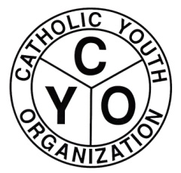

CYO DIOCESAN TRACK LEAGUE
2021 CROSS COUNTRY TEAM REGISTRATION FORM

MEETS

HALF-MILE RACES: 9/26/2021 CROSS COUNTRY CLASSIC: 10/3/2021
SECTIONAL MEET: 10/17/2021 DIOCESAN MEET: 10/24/2021

ALL FOUR MEETS WILL BE HELD AT ALLEY POND PARK, SPRINGFIELD BLVD. & 76 AVE.

FIRST RACE TO BE RUN AT 12 NOON. CHECK-IN AT 11:15AM IMMEDIATELY FOLLOWED BY THE COACHES MEETING.

PARISH/TEAM NAME: _______________________________________________

BOYS:__________ GIRLS:___________ (Check one or both)

COACH NAME AND ADDRESS: ___________________________________________
(Please print) ___________________________________________
___________________________________________
PHONE NUMBER: ___________________________________________
E-MAIL ADDRESS: ___________________________________________

We hearby certify that the competitors submitted to CYO on our roster are eligible to represent the parish in accordance to the Rules and Regulations of CYO.

COACH/AD SIGNATURE: ________________________ DATE:_______
PAR SIGNATURE: _______________________ DATE:_______

THIS FORM MUST BE MAILED TO THE CYO OFFICE NO LATER THAN 9/17/2021.

CYO DIOCESE OF BROOKLYN
7200 DOUGLASTON PARKWAY
DOUGLASTON, NY 11362
ATTN: KEITH GOLDBERG

